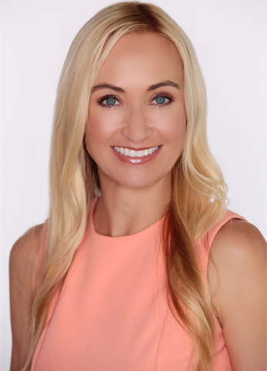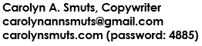

Career Objective and Philosophy

I’m a highly experienced copy, business, and technical writer seeking a position where I can use my extensive B2B, B2C, and Public Relations writing experience to connect with people in a meaningful, measurable way. Words matter; they are the key to transcending the noise and connecting brands with real humans in our information-dense world.

Professional Experience

DrJ International
Lead Copywriter/Marketing Specialist (October 2020-Present)

- Own all aspects of copy across the primary brand and 5 separate affiliated brands
- Compose meaningful, relatable SEO-friendly content for web, blogs, Amazon, and affiliates
- Develop full-funnel eComm campaigns driving growth and awareness
- Determine marketing direction and execute corresponding digital and PR campaigns
- Compose all brand copy, including ads, eComm, packaging, new product launches, visual merchandising, retail displays, advertising, and educational collateral, as well as all website and digital assets

Best Version Media - Staff Writer (September 2020-Present)

- Compose monthly long-form columns for 3 local magazines

Estée Lauder Company/Too Faced Cosmetics, Irvine, California
Lead Copywriter (2017-October 2020)

- Winner: CEW #1 Digital Launch of 2020 for Born This Way The Natural Nudes Palette
- Compose all company copy, including but not limited to packaging, web, eComm, marketing, and sales materials
- Launch the brand in Asia, including China (T-Mall, Hong Kong, and cross-border campaigns), Korea, and Japan
- Act as sole department liaison with the Estée Lauder legal team, ensuring compliance of output
- Manage a team of copywriters in a fast-paced, deadline-driven environment
- Develop the first-ever style guide for the brand
- Implement SEO best practices across all digital copy
- Develop print collateral copy to support campaigns across departments, including training documents, tutorials, marketing promotions, in-store collateral, and mailers
- Create video scripts for training, social channels, seasonal launches, and ads
- Develop large-scale global outdoor advertising strategies, including campaigns in New York, London, and LA
- Manage planning and execution of ongoing full-funnel digital marketing campaigns
- In my time as Lead Copywriter, Too Faced products became:

- The #1-selling prestige mascara in the U. S. and 8 additional countries
- The #1-selling lip gloss in the U.S. and 6 additional countries
- The #2 overall brand at Sephora

Billion Dollar Beauty Inc., Irvine, California
Director of Global Relations/Copywriter (2011-2017)

- Launch & grow brand globally, including Australia, New Zealand, the UK, Japan, Ireland, South Africa & Russia
- Create content for all social media platforms
- Maintain a daily long-form blog more than 4 years
- Write full-length published book on behalf of founder
- Maintain productive relationships with all key international distributors, influencers, and press outlets in 20 countries

NEAD, Inc., Huntington Beach, California
Marketing Director (2009-2012)

Communicate multiple brand marketing and product messages in an engaging and relevant manner for a bespoke tech company with a focus on user experience and technology. Fulfilling the primary goal of the company founder, NEAD’s flagship MyCivic app was acquired by Tyler Technologies, the largest software company in the US solely focused on providing software services to the public sector.

Independent Contractor: Writing and Editing (Various Clients) (2008-2017)

Specializing in business and professional services including ad copy, marketing and PR materials, non-fiction books, brochures, creative copywriting, catalogs, press releases, and print collateral

On behalf of clients, articles published in (among others) Bloomberg Business, Self, Glamour, Better Homes and Gardens, Ultimate Motorcycling, and Family Circle; online articles published on SheKnows and PopSugar, articles published in The Los Angeles Times, The Orange County Register, The Ventura County Star, and the Ventura County Reporter.

CSU, Fullerton Editorial Advisory Board (1997-2006)

Instruct students in all aspects of academic editing and publishing through the University’s perennially award-winning academic journal, The Welebaethan: A Journal of History, published by undergraduate and graduate scholars in the Department of History at California State University, Fullerton.

EDUCATION

Master of Arts, History, California State University, Fullerton
Bachelor of Arts, History, California State University, Long Beach
Ghostwriter Professional Designation Certificate

(Intensive 6-month training program focused on publishing law, the business of books and publishing, theory, skill sets, ethics, and manuscript marketing)

